Application Form JUNE 2023
The process “emblematic projects showcases” is the label for promoting projects of excellence in the industry of the future, materializing a clear partnership between a French company and a German company. This label aims to serve as an example and model for the transformation of industry and international development. Participation in this call for applications is free and open to all companies, subject to the criteria defined in the call for applications.
Stakeholders of the project
About the French company
Corporate name
Localisation
Date of creation
Website
Workforce
Sales Turnover
Name of the holding
Branch Office in Germany | ☐ YES ☐ NO
Description of the company
Industrial sector
Typology | ☐ SME ☐ ISEs ☐ Large company ☐ Start-up
About the French legal representative
Name
First Name
Position
Email
Phone number
About the German company
Corporate name
Localisation
Date of creation
Website
Workforce
Sales Turnover
Name of the holding
Branch Office in France | ☐ YES ☐ NO
Description of the company
Industrial sector
Typology | ☐ SME ☐ ISEs ☐ Large company ☐ Start-up
About the German legal representative
Name
First Name
Position
Email
Phone number

Description of the project
Executive summary of the project

Which partners are involved in this project (companies, subcontractors, laboratories, research centers, enablers, institutions) ?

In which technological field does your project fit (one or more) :
Domain | Description
Digital chain: digital twins, digital spaces, edge management, systems engineering | ☐
Advanced production technologies, additive manufacturing | ☐
Automation, innovative and intelligent machines, cobotics, virtual and augmented reality, robotics | ☐
Distributed systems and IT: 5G industrial blockchain, cybersecurity, IoT, cyber-physical systems | ☐
I/A: big Data, chatbot, data science for industry, machine Learning | ☐

What issues does your project address (one or more) :
Domain | Description
Sustainability of industrial processes, decarbonization of production along the value chain | ☐
New economic and social models: co-innovation, circular economy, innovation in the supply chain, continuity | ☐
New approaches to people at work: collaborative applications, training in the new skills of the industry of the future, change management | ☐

According to you, in what way can your project be an “emblematic project showcase”? How can it serve as an example for the future of industry and inspire the French sector to export? How is it part of a strategic approach? What are the impacts of your projet to your structure

Additional comments

In addition to this information, please provide, if possible, the Jury with potential additional information about your project : synthetic presentation slides, synthetic documentation, press article, photos, videos (to be sent to nathanael.pierret@industrie-dufutur.org)
Date :  Signature of the French Company : | Date :  Signature of the German Company :

IN partnership with

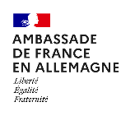
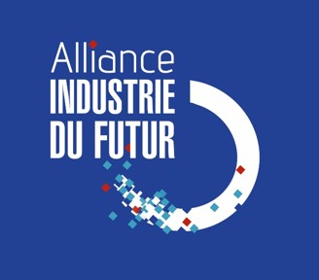
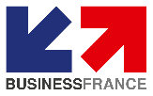

Created in 2015, the Alliance Industrie du Futur (AIF) is an association which organize and coordinate, at the French level, the initiatives, and projects of SMEs and companies for the modernization of industrial tools and the transformation of their business model, particularly through the contribution of new technologies.

